

DESIGN STAGE 2 SAMPLE EXAMINATION

Section 7 of the New WACE Manual: General Information 2006–2009 outlines the policy on WACE examinations.

Further information about the WACE Examinations policy can be accessed from the Curriculum Council website at http://newwace.curriculum.wa.edu.au/pages/about_wace_manual.asp.

The purpose for providing a sample examination is to provide teachers with an example of how the course will be examined. Further finetuning will be made to this sample in 2008 by the examination panel following consultation with teachers, measurement specialists and advice from the Assessment, Review and Moderation (ARM) panel.

input.doc




Western Australian Certificate of Education, Sample External Examination
Question/Answer Booklet

DESIGN
Please place your student identification label in this box
WRITTEN PAPER
STAGE 2

Student Number: In figures

In words

Time allowed for this paper
Reading time before commencing work: Ten minutes
Working time for paper: Two hours and thirty minutes

Materials required/recommended for this paper
To be provided by the supervisor
This Question/Answer Booklet

To be provided by the candidate
Standard items: Pens, pencils, eraser or correction fluid, ruler, highlighter

Important note to candidates
No other items may be taken into the examination room. It is your responsibility to ensure that you do not have any unauthorised notes or other items of a non-personal nature in the examination room. If you have any unauthorised material with you, hand it to the supervisor before reading any further.

Structure of this paper

Section | Suggested working time | Number of questions available | Number of questions to be attempted | Marks available
Section One:  Short response | 60 minutes | 40 | 10 | 40
Section Two:  Extended response | 90 minutes | 8 | 2 | 60
 |  |  | [Total marks] | 100

Instructions to candidates
- The rules for the conduct of Curriculum Council examinations are detailed in the Student Information Handbook. Sitting this examination implies that you agree to abide by these rules.

- For Section 1, you are to answer the questions in the space provided immediately after each question in this Question/Answer Booklet

- For Sections 2, write your answers in a separate Answer Booklet. A blue or black ballpoint or ink pen should be used.

- You must be careful to confine your responses to the specific questions asked and to follow any instructions that are specific to a particular question.

- Spare answer pages may be found at the end of this booklet. If you need to use them, indicate in the original answer space where the answer is continued (i.e. give the page number).

SECTION ONE—SHORT RESPONSE 40%

In this section there are FORTY (40) questions. This section contains FOUR (4) contexts.
SELECT ONE CONTEXT ONLY. Answer all questions in that context.

Allow approximately 60 minutes for this section [40 marks].

CONTEXT 1: PHOTOGRAPHY [40 marks].

Question 1
Identify four ways in which a photographer could build a profile of a target audience.
[4 marks]

Question 2
Explain how social and cultural changes overtime can affect the way in which food is photographed.
[4 marks]

CONTEXT 1: PHOTOGRAPHY

Question 3
In advertising photography, outline three considerations for a successful advertisement.
[3 marks]

Question 4
List five communication environments.
[5 marks]

Question 5
Outline one technological development that has influenced photographic practice.
[3 marks]

CONTEXT 1: PHOTOGRAPHY

Question 6
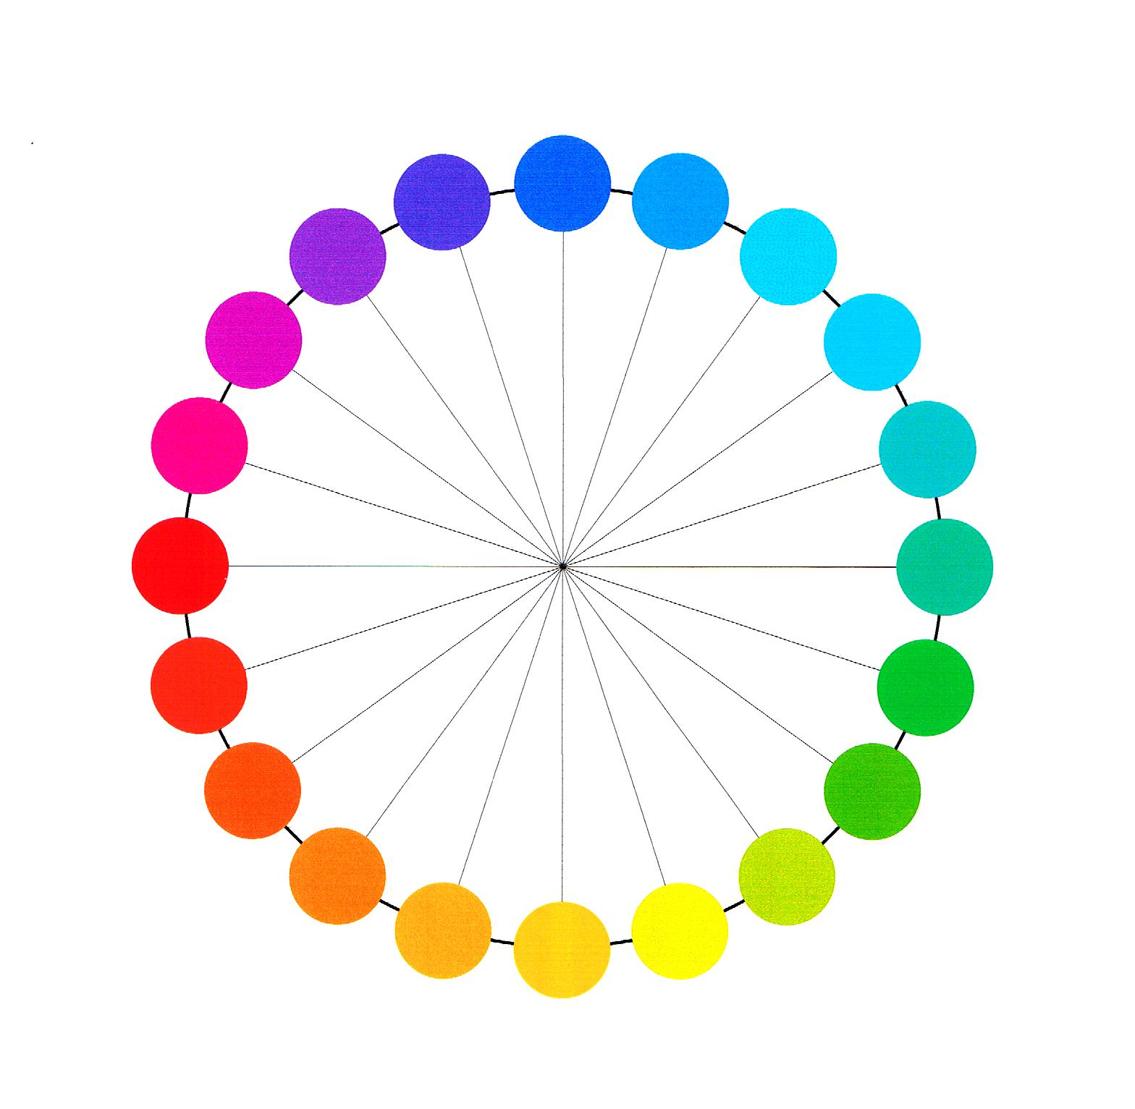
[From: P. Green-Armytage]
Look at the colours on the colour wheel ABOVE and answer the following:

- Choose any two complementary colours. Explain how they could be used to create an effect.
[2 marks]
Colours chosen: and

CONTEXT 1: PHOTOGRAPHY

- Give two examples of warm colours. Explain how they could be used to create a specific atmosphere or effect.
[2 marks]

Question 7
Explain the meaning of each of the following in terms of colour: hue, tone, saturation
[5 marks]

Question 8
Select either hue, tone or saturation and describe an example of its application.
[3 marks]

CONTEXT 1: PHOTOGRAPHY

Question 9
This question refers to the images below.

(a)
(b)

(d)
(c)

[From: A. Price]

Explain how the use of colour in the four identical pictures could affect the way in which we perceive it and describe the emotions or reactions evoked by the colour in each picture
[5 marks]

CONTEXT 1: PHOTOGRAPHY

Question 10
Explain two aspects of a communication model that can be applied to help read or construct a message.
[4 marks]

THIS SPACE HAS BEEN LEFT BLANK INTENTIONALLY

SECTION ONE—SHORT RESPONSE 40% (cont.)
CONTEXT 2: GRAPHIC

Question 11
Identify 6 areas of focus in designing a magazine advertisement for a new shoe for a child, that will attract the target audience.
[6 marks]

Question 12
You have found an image in a book which you would like to use as part of an article you are writing for a daily newspaper. What steps would you need to take to be able to do so legally?
[3 marks]

CONTEXT 2: GRAPHIC

Question 13
Below is an image of the Australian flag. Briefly analyse the design elements and principles of language used.
[5 marks]

For copyright reasons this image cannot be reproduced in the online version of this document but may be viewed at http://www.australiaday.gov.au/pages/page22.asp
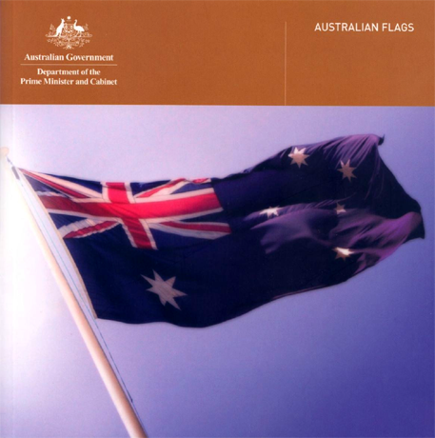
From: Department of Prime Minister and Cabinet, 1998

CONTEXT 2: GRAPHIC

Question 14
Using the same flag image, state what values, beliefs and attitudes the flag designer might have been trying to portray.
[5 marks]

Question 15
A major graphic design publication has decided to discontinue their print publication and go completely online. State advantages or disadvantages this could bring?
[4 marks]

CONTEXT 2: GRAPHIC
Question 16
List four environmental considerations which should be thought about when designing packaging.
[4 marks]

Question 17
In a large design firm there will be many areas of specialisation and many job descriptions. List three of them, giving a short description of the job.
[3 marks]

Question 18
A bus timetable leaflet showing times and routes is being produced by the council for distribution to local homes. List 3 minority groups of people which this leaflet may have to cater for and how it could do this.
[3 marks]

CONTEXT 2: GRAPHIC

Question 19
Explain the meaning of the statement ‘form follows function’.
[3 marks]

Question 20
A client has asked you to create a leaflet for the provision of handicapped services to local council residents. These include the partially sighted and those with physical and mental disabilities.

List four design constraints/considerations you would address in creating the design.
[4 marks]

SECTION ONE—SHORT RESPONSE 40% (cont.)
CONTEXT 3: TECHNICAL GRAPHICS

Question 21
A client has asked you to develop a major design project intended to get a response from a targeted audience. Identify an audience and describe what theories you would use and how you would justify their use to your client.
[6 marks]

Question 22
Describe what techniques can be used to determine the needs and wants of a client before the design stage of a project
[2 marks]

CONTEXT 3: TECHNICAL GRAPHICS

Question 23
Choose a graphics style or method (these could include measured perspective, floor plans, technical drawings, typographic design, or any other that you are familiar with) and:
- Explain at least two applications of the graphics style or method in industry and society.
- Explain who would create these graphics types.
- Explain why these particular graphics types are used, how they are used, and who would be the end users.
[6 marks]

Question 24
A client has asked you to create a proposal for the provision of handicapped services to local council residents. These include the partially sighted and those with physical and mental disabilities.

List THREE points concerning the design constraints/considerations you would address in creating the design.
[3 marks]

CONTEXT 3: TECHNICAL GRAPHICS

Question 25
What is the most important legal constraint to consider when publishing a document such as a plan?
[3 marks]

Question 26
Name THREE elements of a design that could have cultural significance and give examples of the way that culture can be expressed in these elements.
[6 marks]

CONTEXT 3: TECHNICAL GRAPHICS

Question 27
Name three lifestyle preferences that could be considered when designing a sports oriented product.
[3 marks]

Question 28
Select an advanced material e.g. a composite, a special alloy, a laminated material or other material that you may be familiar with. Give examples of where this material could be used. Describe its properties and give advantages and disadvantages of its use.
[7 marks]

CONTEXT 3: TECHNICAL GRAPHICS

Question 29
Name TWO types of communication and give examples illustrating the way that a designer would use each type.
[2 marks]

Question 30
Name four important economic factors that have to be considered when designing a product.
[2 marks]

SECTION ONE—SHORT RESPONSE 40% (cont.)
CONTEXT 4: DIMENSIONAL

Question 31
Describe either the advantages or disadvantages of using traditional craft techniques such as silk screening, pen drawing, clay modelling or others that you may have used, compared with digital applications. Make reference to the ways in which audiences respond to the media that you chose.
[2 marks]

Question 32
Choose a graphics style or method (these could include measured perspective, floor plans, technical drawings, typographic design, or any other that you are familiar with) and:

1) Explain at least two applications of the graphics style or method in industry and society.
2) Explain who would create these graphics types.
3) Explain why these particular graphics types are used, how they are used, and who would be the end users.
[6 marks]

CONTEXT 4: DIMENSIONAL

Question 33
A client has asked you to create a proposal for the provision of handicapped services to local council residents. These include the partially sighted and those with physical and mental disabilities.

List FOUR points concerning the design constraints/considerations you would address in creating the design.
[4 marks]

Question 34
List THREE common issues for a designer to consider when designing a project
[3 marks]

CONTEXT 4: DIMENSIONAL

Question 35
[From: P. Green-Armytage]
Look at the colours on the colour wheel ABOVE and answer the following:

- Choose any two complementary colours. Explain how they could be used to create an effect.
[2 marks]
Colours chosen: and

CONTEXT 4: DIMENSIONAL

- Give two examples of warm colours. Explain how they could be used to create a specific atmosphere or effect.
[2 marks]

Question 36
Explain the meaning of each of the following in terms of colour: hue, tone, saturation
[3 marks]

Question 37
Select either hue, tone or saturation and describe an example of its application.
[3 marks]

CONTEXT 4: DIMENSIONAL

Question 38
Give four examples of values and beliefs that drive design practice and briefly describe how they affect design
[8 marks]

Question 39
Describe what techniques can be used to determine the needs and wants of a client before the design stage of a project
[3 marks]

CONTEXT 4: DIMENSIONAL

Question 40
What is the most important legal constraint to consider when publishing a design such as a plan, garment design, sketch proposal?
[4 marks]

END OF SECTION ONE

SECTION TWO—EXTENDED RESPONSE 60%

In this section there are EIGHT (8) questions. This section contains FOUR (4) contexts. Complete TWO (2) questions in ONE (1) context.

Allow approximately 90 minutes for this section [60 marks].

CONTEXT 1: PHOTOGRAPHY

Question 41
Photographs are often designed to convey a message to the viewer. Communication theories and other established design principles are used to construct meanings.

Using your exam portfolio, select one of your projects and address the following key points:
- Describe how the project has used design elements and principles to communicate
- Identify and discuss any relevant parts of communication theories demonstrated in your work
- Discuss the use of colour or other design elements that express meaning
- Describe the possible target audience
- Reflect on any social values dealt with in the project
- Discuss meanings or messages conveyed.
[30 marks]

Question 42
You have been asked by a design company to produce an advertisement that attempts to subvert messages of major producers whose practices are deemed to be unethical. Choose one producer from the numbered list below and write a description of how you would address these key points:
- Describe the stages of the design process
- What background research would be required and discuss target audience
- Describe how you would use a communication process
- Construct your design to communicate a message
- Employ relevant design principles
- Convey contemporary social values, representations and culture in your design.

  - Alcohol companies who glamourise smoking and drinking
  - Clothing companies that may employ third world labour or take part in unorthodox methods like those associated with the fur trade.
  - Beauty industry that promotes an unhealthy obsession with being thin
  - Companies that employ animal testing of their products.
[30 marks]

Context 2: Graphic

Question 43
Graphic images are often designed to convey a message to the viewer. Communication theories and other established design principles are used to construct meanings.

Using your portfolio you are to select one of your design projects and analyse it using the following key points:
- Describe how the project has used design elements and principles to communicate
- Identify and discuss any relevant parts of communication theories demonstrated in your work
- Discuss the use of colour or other design elements that express meaning
- Describe the possible target audience
- Reflect on any social values dealt with in the project
- Discuss meanings or messages conveyed.
[30 marks]

Question 44
You have been asked by a design company to produce an advertisement that attempts to subvert messages of major producers whose practices are deemed to be unethical. Choose one producer from the numbered list below and write a description of how you would address these key points:
- Describe the stages of the design process
- What background research would be required and discuss target audience
- Describe how you would use a communication process
- Construct your design to communicate a message
- Employ relevant design principles
- Convey contemporary social values, representations and culture in your design.

  - Alcohol companies who glamourise smoking and drinking
  - Clothing companies that may employ third world labour or take part in unorthodox methods like those associated with the fur trade.
  - Beauty industry that promotes an unhealthy obsession with being thin
  - Companies that employ animal testing of their products.
[30 marks]

Context 3: Technical Graphics

Question 45
Product designs and architectural schemes are often designed to convey a message to the viewer. Communication theories and other established design principles are used to construct meanings.

Using your exam portfolio you are to select one of your projects and analyse it using the following key points:
- Describe how the project has used design elements and principles to communicate
- Identify and discuss any relevant parts of communication theories demonstrated in your work
- Discuss the use of colour or other design elements that express meaning
- Describe the possible target audience
- Reflect on any social values dealt with in the project
- Discuss meanings or messages conveyed.
[30 marks]

Question 46
Describe how you would use measurement categories such as demographics and/or ergonomics (and/or any other measurement that you are familiar with) to create a profile of the user or users for a design work. You can refer to your portfolio for this.
[30 marks]

Context 4: Dimensional

Question 47
Product designs, fashion, textiles, jewellery, architecture and other dimensional subjects are often designed to convey a message to the viewer. Communication theories and other established design principles are used to construct meanings.

Using your exam portfolio you are to select one of your projects and analyse it using the following key points:
- Describe how the project has used design elements and principles to communicate
- Identify and discuss any relevant parts of communication theories demonstrated in your work
- Discuss the use of colour or other design elements that express meaning
- Describe the possible target audience
- Reflect on any social values dealt with in the project
- Discuss meanings or messages conveyed.
[30 marks]

Question 48
Describe how you would use measurement categories such as demographics and/or ergonomics (and/or any other measurement that you are familiar with) to create a profile of the user or users for a design work. You can refer to your portfolio for this.
[30 marks]

ACKNOWLEDGEMENTS

SECTION ONE

CONTEXT 1: PHOTOGRAPHY

Question 6: Colour wheel by kind permission Paul Green-Armytage.
Published by the Curriculum Council of Western Australia
27 Walters Drive
OSBORNE PARK WA 6017

Question 9: Images by kind permission Alun Price.

CONTEXT 2: GRAPHIC

Question 13: Department of Prime Minister and Cabinet. (1998). Australian flags (Cover). Retrieved July, 2007, from Australia Day website: http://www.australiaday.gov.au/pages/page22.asp.

CONTEXT 4: DIMENSIONAL

Question 35: Colour wheel by kind permission Paul Green-Armytage.

